**From:** [[MCDSKeane@gmail.com](mailto:MCDSKeane@gmail.com)]  
**To:** [LSSnowtrails@gmail.ie](mailto:LSSnowtrails@gmail.ie)**Date:** [13/November/2024]  
**Subject:** Three visual impairment aids for Snow Trails Travel Agency website

Dear Lucas,

I hope this email finds you well.

We are pleased that you find our work to your standards, and we strive to continue to impress you,

Taking your suggestion to further the accessibility of the website, we followed up with using Lighthouse to test the website and are pleased to have achieved a score of 100 on both desktop and mobile devices.

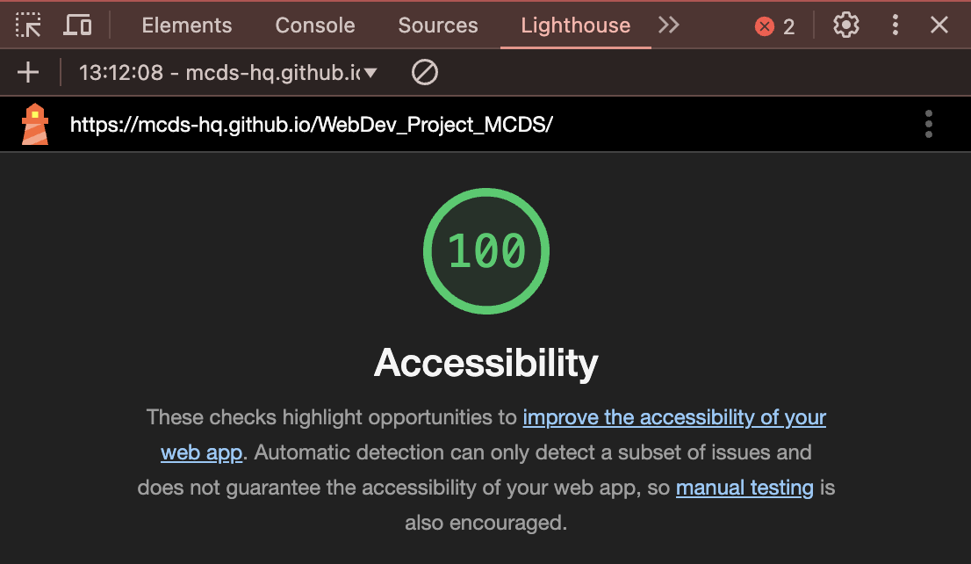

(Proof of claims)

We also adjusted the site layout, adding improved accessibility and responsiveness on other devices such as phones and tablets.

The new page we added follows the same format as the other three, but it caters to your request of talking about how great blind skateboarders can be.

[**Clicke here to go to the website**](https://mcds-hq.github.io/WebDev_Project_MCDS/)

Best regards,

[David Keane]  
[0853817261]  
[[MCDSKeane@gmail.com](mailto:MCDSKeane@gmail.com)]  
[MCDS.gov]